Memories from the Fjords and beyond by Tom Kyvik
My name is Tom Kyvik and I am a part of the Norwegian Connection. I am very grateful towards Fred (Farrow) and Torbjørn (Eriksen) for sharing details of the website with me. The website is just very good, giving me nice memories – and a lot of interesting reading!
For me it all started when I was 17 in 1961. My teacher in English happened to be “International Commissioner” in the Norwegian Scout Association (NSF). He asked me and a close friend (Tedd Johansen) if we wanted to join English and Danish scouts going to camp in Snowdonia – and so we did. I have enclosed a clip from The Streatham News, telling more about it. “Pip” Rands was in charge. He wrote a detailed log (which he later gave to me, 138 hand written pages!), and the paper cutting was in it. The scouts were from the 26th Streatham (St Paul’s). I have pictures, but suppose this is going too far back – and the 26th is not mentioned on the web site.  Pip and I kept in touch, and in 1963 he was very helpful to find a place for me to live as I was going to work in Uxbridge for a year. I stayed at Harrow, but saw Pip frequently. He introduced me to Jim (Cranham), his nephew – and there were many visits and revisits as long as Pip and Jim lived. I have pictures from two scout weekends in 1963: At Downe in October with the 3rd Streatham, Seniors and Rovers, and a trip on the Thames with Ray Perkins and his Sea Scouts in November.  (Tom’s photos can be found at http://thenearpost.com/gallery047.html ) | 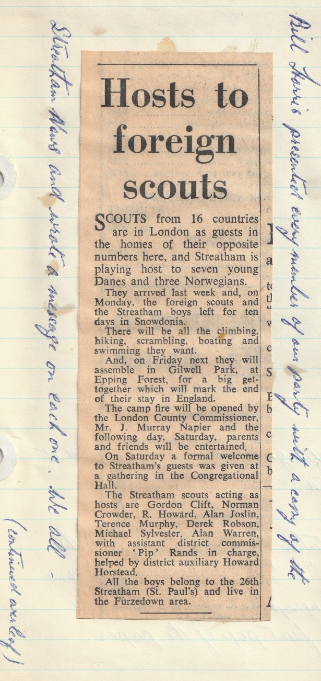

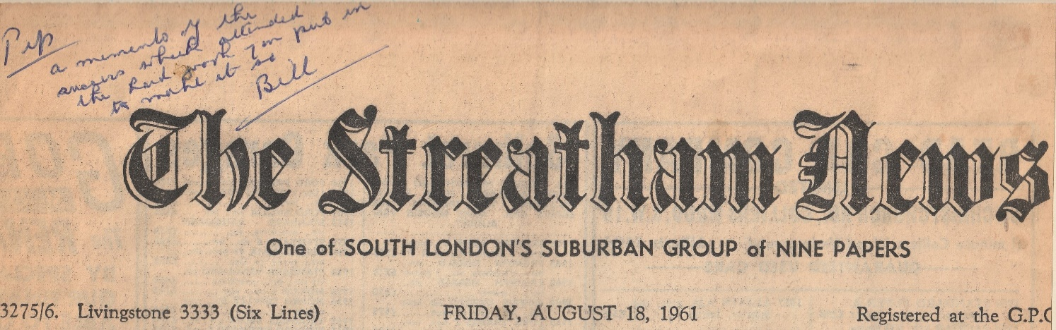
As to the campsite at Downe, I think I read somewhere on the web site that Downe was in danger of being sold. I fully support that this grand camp site must remain being owned by the Scout movement! I enclose 5 photos – including one of Jim and his Herald Triumph. Nice car! I’m sorry not to have any names of the chaps – apart the one of Jim, Pip and me.
As to Downe: I had never heard about "The Gang Show" until my landlady at Harrow in 1963 offered me a ticket. Off I went - to Golders Green Hippodrome - and a fantastic show and music :) I had a great time - and so had Vera Lynn and Lady Olave Baden-Powell ... ! It was not till later I learned the following, quote from Wikipedia: “Downe Camp, close to Orpington, opened in 1929 as a Scoutmasters' Training Ground. From 1933 it was available to Scout Groups and the site offered camping and some activities, including swimming. This was possible by the construction of a swimming pool which was funded by the proceeds from the very first Gang Show, which was organised by Ralph Reader for this very purpose”. - I didn't jump into that swimming pool when I was at Downe in autumn 1963 - but it was a great camp site!
I’m not sure if the trip on the Thames was a joint 4th and 3rd Streatham event – or only Sea Scouts plus Jim and me – and I don’t know if the Sea Scouts are included in the SVSU. Anyway, there are six pictures for the website. The “river cruise” was from Sunbury although it turned out that the river was in flood, so we didn’t go beyond Kingston.
My parents used to have a small summerhouse at Hauketo, close to Oslo. In 1966 this was used by Streatham Seniors/Rovers on two occasions. On 29th July, John Bowden and Ian Janes came by train from Kristiansand, whilst Julian Ben-David, Bob Stent and John Heather came by car (I don’t know from where). My diary records that they stayed for two nights and we watched the World Cup final from Wembley with England beating (West) Germany 4-2.
On the 4th August in 1966 a mini bus (Ford Transit I think) came (to Norway) crammed with scouts from the 3rd Streatham.
I don’t know where they went after their stay in Oslo. However, Jim, Ray, Peter Appleford and Bruce visited Torbjørn Eriksen and the 4th Lambertseter Group at the district camp at Vatningsseter, Nord-Odal. The SVSU gallery has a picture of Torbjørn writing down the address of a future pen pal (Fred).
We had a new visit from the 3rd Streatham (Livingstone VSU) in 1968. They stayed at my parents’ summerhouse a couple of days before going to the national jamboree at Jørstadmoen, near Lillehammer.
Finally, I enclose the only picture I have of Jim, Pip and Ray together. The others are Jim’s parents and my mother in front. It is from 1970 when my parents visited London. However, nice, but not quite related to SVSU…
This Anglo-Norwegian relationship has given me so many pleasant memories!
As we put it “in the olden” days -
“Yours in Scouting”,
Tom

Note the telephone number for the Streatham News – “Livingstone 3333”
This reference to the future of Downe via an external Facebook page link was removed in early December 2020. The future of Downe as a Scout Association owned facility remains the same as at the beginning of 2021.
From the photos, it looks like a combined activity.
It may not be a Scouting activity, but it contains three revered Gentlemen from Streatham’s Scouting family.

